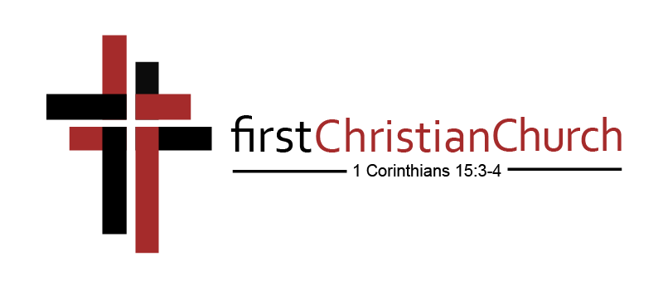

**Essential Doctrinal Statements**

Our doctrinal statements are beliefs and theological positions drawn from the Bible. These beliefs are nonnegotiable for membership at First Christian Church.

**GOD**

We believe that God is the Creator and Ruler of all things. He eternally exists in three persons: The Father, The Son, and The Holy Spirit – each with distinct attributes, but without division of nature, essence, or being. God is eternal, all-powerful, all-knowing and ever-present. He is perfect in love, justice, and holiness, and worthy to receive all glory, honor, and praise.

*Matthew 28:19; 2 Corinthians 13:14; 1 Peter 1:1-2*

**GOD the FATHER**

God the Father equally shares the godhead with the Son and the Holy Spirit. The Father’s work in our salvation is manifested in His all-knowing, all-powerful, ever-present love The Father creates, yet by and through the Son. The Son redeems, yet commissioned by the Father, The Spirit inspires and sanctifies, yet as sent by the Father and the Son. The Father is always working His good pleasure for the redemption of His creation even before creation was formed. All power and authority originate from the Father. He is the One who chooses or “elects” those whom He desires to receive mercy and grace. God, the Father, has chosen to be our Father. He chose to make us His sons and daughters because it pleased Him to do so. It is through the Father that the covenant of grace has been established for the redemption of man.

*Psalm 33:6; Romans 1:20, 11:33-36; 1 Corinthians 8:6; Ephesians 1:3-5, 19; 1 John 3:1*

**GOD the SON – JESUS**

God the Son is Jesus Christ. While eternal in nature, His incarnation was conceived of the Holy Spirit and He was born of the virgin Mary. Jesus of Nazareth is the Messiah, the Son of the Living God, God in human form, and both fully God and fully man. Jesus perfectly revealed and lived out the will of God, taking upon Himself human nature without sin. He offered Himself as the perfect sacrifice for sin and through His death made provision for the redemption of humanity from sin. He died for our sins, was buried, was raised from the dead, and appeared to His disciples proving His power over death and His ability to raise us up from death. He ascended into Heaven to the right hand of God the Father where He mediates reconciliation between God and humanity. He will physically return in power and glory to judge the world and consummate His redemptive mission.

*John 1:1, 14, 8:58, 14:9; Colossians 2:9; Philippians 2:5-7 3.*

We believe in the literal, bodily resurrection of Jesus from the dead.

*1 Corinthians 15:1-4 4.*

We believe in the literal return of Jesus as promised.

*John 14:1-6; 1 Thessalonians 4:16-18; 2 Peter 3:3-4, 10, 13*

**GOD the HOLY SPIRIT**

God the Holy Spirit is fully divine. He inspired the writers of the Scriptures. He convicts the world of sin, righteousness, and judgment. He enables Christians to understand truth. He dwells in the hearts of every Christian from the moment of salvation. He bestows spiritual gifts on believers through which they serve His church. He comforts and intercedes for them. He is the seal to the believer for the day of redemption. He enlightens and empowers the believer in the church in worship, evangelism, and service.

*Acts 2:38; Romans 8:26-27; 1 Corinthians 12:4-11; Galatians 5:22-23; Ephesians 1:13-14*

**THE BIBLE**

We believe that the Bible is the inspired Word of God, the written record of His supernatural revelation of Himself to man, absolute in its authority, complete in its revelation, final in its content, and without any error in its teaching.

*2 Timothy 3:16-17; 2 Peter 1:20-21 Updated September 2018*

**HUMANITY**

We believe that all humanity is born with a sin nature.

*Jeremiah 17:9; Romans 3:23 8.*

We believe in the substitutionary death of Jesus on the cross to atone for the sins of humanity.

*Isaiah 53:3-6; Romans 5:8; 2 Corinthians 5:21*

**SALVATION**

We believe that the forgiveness of sins and the gift of eternal life are promised to those who trust Jesus Christ as their Lord and Savior.

*John 3:16-17; Ephesians 2:8-9 10.*

We believe that those putting their trust in Jesus should repent of their sins, confess their faith, and be baptized into Him.

*Acts 2:38-39; Romans 6:3-4, 10:9 11.*

We believe that those who receive Jesus also receive the indwelling of the Holy Spirit. He marks them as the possession of God, manifests the fruit of righteousness in their character, and endows them with spiritual gifts for ministry.

*1 Corinthians 12:4-6; 2 Corinthians 1:21-22; Galatians 5:22-23 12.*

We believe that a spiritual gift is a special ability, given by the Holy Spirit to every believer, to be used to minister to others and thereby build up the body of Christ.

*Romans 12:6-8; 1 Corinthians 12:7-11; 1 Peter 4:10*

**THE CHURCH**

We believe the Church is a body of Christ-followers who should live in intentional community as modeled by the first century church.

*Acts 2:42-47 14.*

We believe love is to be shown to all people as the central trait of the Christian faith.

*John 13:35; 1 Corinthians 13:13; 1 Peter 4:8 15.*

We believe the mission of the Church is to make disciples who love God and others, to teach with the goal of forming Christ in them, and then to mobilize believers to accomplish God’s purposes in the world.

*Matthew 28:18-20 16.*

We believe that unity is necessary for the church to accomplish the mission given by Jesus.

*Matthew 28:18-20; John 17:20-21; 1 Corinthians 1:10; Ephesians 4:1-5*

**ETERNITY**

We believe that Heaven and Hell are real places and each of us will spend eternity in one place or the other, whether in the in glorious presence of God or forever separated from His love and eternal joy.

*2 Corinthians 5:6-10; 2 Thessalonians 1:8-9; Hebrews 9:27; Revelation 20:15*